KIRA DIVINE RELEASES HIGHLY ANTICIPATED SINGLE AND VIDEO FOR
“MY SEASON”

AFTER MAKING WAVES ON BILLBOARD CHARTS IN EDM KIRA DIVINE STEPS OUT AS AN
INDEPENDENT ARTIST WITH DEBUT SONG

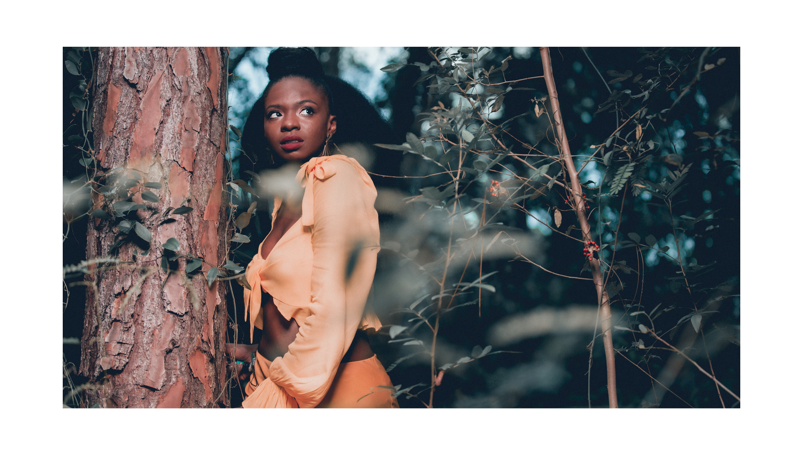
WATCH “MY SEASON” HERE
Coming off the heels of her multi-platinum success with Australian EDM band PNAU, Kira Divine releases her debut single and music video entitled “My Season” on all digital platforms. This first single is a small sample of the soundscape one can expect from her highly anticipated debut album “Divinity” set to release in 2021. As an independent artist, Kira has taken this opportunity to return to her Guyanese roots - Afro Soca style, a term she coined that reflects her diaspora cultural influences. Produced by Joey 2 Kool (Joel Browne) of Georgetown, Guyana Kira has made it her mission to collaborate with local artists in an effort to showcase the unique “cook-up” of talent in her beloved ancestral country.

After four years of touring and releasing hit dance tracks like “Chameleon” which peaked at #4 on Billboard with 8 million views on Youtube; “Go Bang” which peaked at #10 on Billboard with the music video now at 10 million views on Youtube and most recently “Solid Gold” a collaboration with Marques Toliver and Pnau, it is safe to say Kira is ready to share her own personal musical stylings with the world. Working with PNAU members Nick Littlemore and Peter Mayes, Kira provided vocals and songwriting on PNAU’s 2017 Album release “Changa” of which she also starred in the music video for the song with the same title.
In addition, Kira has been featured in a remarkable range of worldwide media outlets and national publications spanning Billboard, The Daily Telegraph, The Daily Mail, The Fader, NBC news and largeup.com. Kira Divine opened the 2017 ARIA awards with a stunning performance alongside PNAU with 3 nominations for her work with the band on “Chameleon”. Kira attended the 2019 ARIA awards with another nomination for Best Dance Song for her work on “Solid Gold”.

Kira Divine states: “My Season is an ode to the strategies I’ve utilized to navigate a system designed to hold back a woman like myself. A survival guide of sorts; a reflection on how I’ve accomplished my goals in the face of adversity. This is my protest. This is my song. This is my season more now than ever before. This is our season to reclaim our space, reclaim our time and reclaim our divine justice, love and life sublime.”

CONNECT WITH KIRA DIVINE
KIRADIVINE.COM
FACEBOOK
INSTAGRAM
TWITTER
YOUTUBE

www.KiraDivine.com

